Example: CRUD operations using Persistence Service using Business Key
DB Table: Z1030EMP
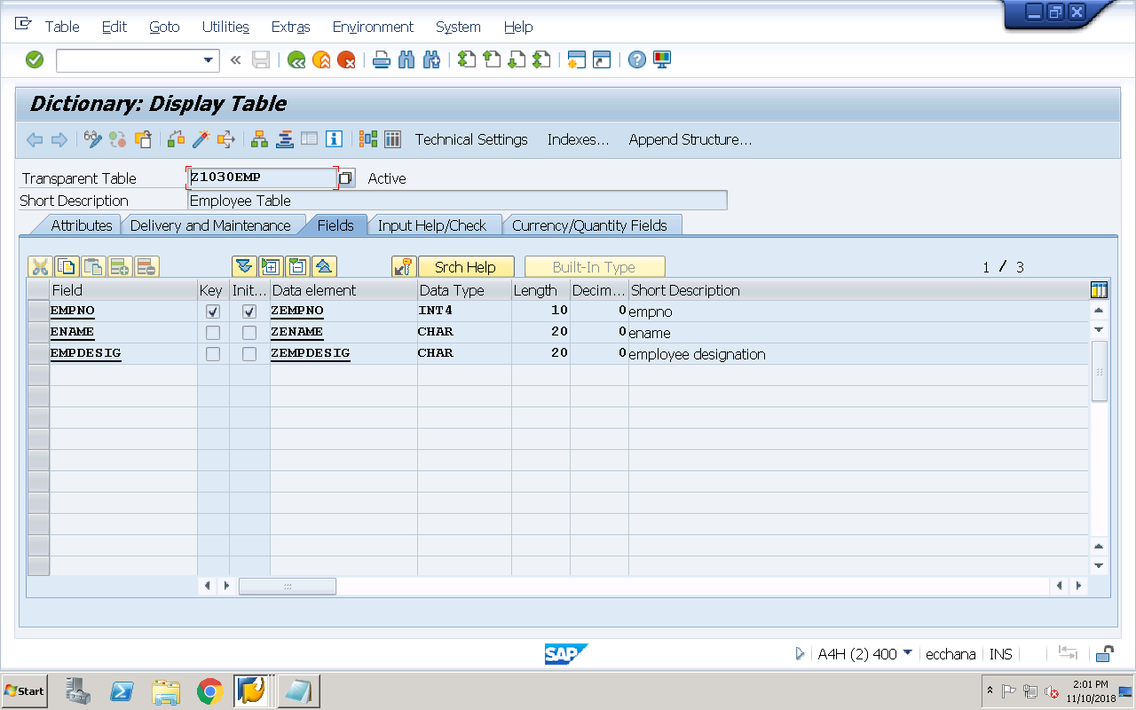
REPORT Z1030OOPS42.
data :o_pers type ref to zcl_1030emp,
o_actor type ref to zca_1030emp.
PARAMETERS : p_empno type z1030emp-empno,
p_ename type z1030emp-ename,
p_desig type z1030emp-empdesig.
SELECTION-SCREEN begin of block bk1 with frame title t1.
PARAMETERS : p_r1 RADIOBUTTON GROUP grp1 USER-COMMAND fc1,
p_r2 RADIOBUTTON GROUP grp1,
p_r3 RADIOBUTTON GROUP grp1,
p_r4 RADIOBUTTON GROUP grp1,
p_r5 RADIOBUTTON GROUP grp1 DEFAULT 'X'.
SELECTION-SCREEN end of block bk1.
INITIALIZATION.
t1 = 'Employee CRUD Operations'.
o_actor = zca_1030emp=>agent.
message 'Actor class object is created' type 'I'.
at SELECTION-SCREEN on RADIOBUTTON GROUP grp1.
case sy-ucomm.
when 'FC1'.
if p_r1 = 'X'.
perform create_persistent_object.
elseif p_r2 = 'X'.
perform delete_persistent_object.
elseif p_r3 = 'X'.
perform modify_persistent_object.
elseif p_r4 = 'X'.
perform read_persistent_object.
endif.
endcase.
FORM create_persistent_object .
TRY.
CALL METHOD o_actor->create_persistent
EXPORTING
i_empno = p_empno
receiving
result = o_pers.
if o_pers is bound. "not initial.
* set the values for non-key fields
TRY.
CALL METHOD o_pers->set_ename
EXPORTING
i_ename = p_ename.
CATCH cx_os_object_not_found .
message 'Object not found for setting ename' type 'I'.
ENDTRY.
TRY.
CALL METHOD o_pers->set_empdesig
EXPORTING
i_empdesig = p_desig.
CATCH cx_os_object_not_found .
message 'Object not found for setting empdesig' type 'I'.
ENDTRY.
commit work. "saves permanently in the DB
endif.
CATCH cx_os_object_existing .
message 'Exception in creating persistent object' type 'I'.
ENDTRY.
ENDFORM.
FORM delete_persistent_object .
TRY.
CALL METHOD o_actor->delete_persistent
EXPORTING
i_empno = p_empno.
commit work.
CATCH cx_os_object_not_existing .
message 'Object not existing for deletion' type 'I'.
ENDTRY.
ENDFORM.
FORM read_persistent_object .
TRY.
CALL METHOD o_actor->get_persistent
EXPORTING
i_empno = p_empno
receiving
result = o_pers.
if o_pers is bound.
clear : p_ename,
p_desig.
* read non-key field values
TRY.
CALL METHOD o_pers->get_ename
RECEIVING
result = p_ename.
CATCH cx_os_object_not_found .
message 'Object not found for reading ename' type 'I'.
ENDTRY.
TRY.
CALL METHOD o_pers->get_empdesig
RECEIVING
result = p_desig.
CATCH cx_os_object_not_found .
message 'Object not found for reading empdesig' type 'I'.
ENDTRY.
endif.
CATCH cx_os_object_not_found .
message 'Object not found for reading based on given empno' type 'I'.
ENDTRY.
ENDFORM.
FORM modify_persistent_object .
* check the existence of persistence object for modification
TRY.
CALL METHOD o_actor->get_persistent
EXPORTING
i_empno = p_empno
receiving
result = o_pers.
if o_pers is bound.
* set non-key field values for modification
TRY.
CALL METHOD o_pers->set_ename
EXPORTING
i_ename = p_ename.
CATCH cx_os_object_not_found .
message 'Object not found for modifying ename' type 'I'.
ENDTRY.
TRY.
CALL METHOD o_pers->set_empdesig
EXPORTING
i_empdesig = p_desig .
CATCH cx_os_object_not_found .
message 'Object not found for modifying empdesig' type 'I'.
ENDTRY.
commit work.
endif.
CATCH cx_os_object_not_found .
message 'Object not found for reading based on given empno' type 'I'.
ENDTRY.
ENDFORM.
Selection-screen texts
